ROYAL OAK INTERNATIONAL SCHOOL
SR. SEC. CBSE AFFILIATED
HOLIDAY HOME WORK (SESSION 2019-20)
Class – III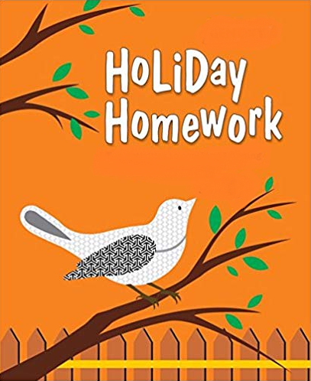

Please note the following:
- HHW of 5 marks will be added as a subject enrichment activity marks in Term I, hence submission of work post summer vacation is compulsory for all the students.
- Schedule for the Submission of HHW for all classes is as follows:
English : 3/07/2019
Hindi : 4/07/2019
Math : 5/07/2019
Science : 8/07/2019
Social Studies : 9/07/2019
- Submission dates for Computer, G.K., Art & Craft will be in the 2nd week of July.

Wishing you all a very fruitful and enjoyable vacations. HAPPY HOLIDAY!

FOR THE PARENTS

Summer Vacations are here. A few vital suggestions are listed below to make the vacations more exciting and fruitful than ever before:
- Keep at least half an hour a day for sharing experiences with your child.
- Encourage your child to speak in English. Fix one hour in a day when you communicate with your child only in English.
- Tell your child different stories regularly and encourage him/her to describe what he/she would do in a similar situation. Here are few suggested titles which you can read with your child.
a. Lacey-the little mermaid fairy d. Giraffe can’t dance
b. I like myself (Story book) e. Dolphins at the day break
c. Panchatantra stories
- Let your child colour, draw, paint, Play, Dance etc.
- Restrict his/her television watching, confining it to interesting children’s program, cartoon films, discovery channel etc.
- To improve the formation of letter, make your child write a page every day.
- Develop self help skills: Let your child dress and feed on his/her own.
- Make him/her understand the importance of cleaning his/her room and putting away toys and belongings after use.
- Take your child out for picnics and to other places of his/her interest. Ask him/her to make a note of all the places he/she visits and things he/she sees so that he/she is able to discuss his/her experience in class after vacations.
Have a nice time!
PRINCIPAL

ENGLISH:
- Learn and write a poem you like the most and draw or paste the related picture on A4 sheet.
- Write 10 homophones with picture on A4 sheet.
- Draw a picture of “Garden” and write 10 sentences about it on A3 sheet.
- Make flash cards for common and proper nouns.(5 for each)
- Read any 5 stories from your story book “A Treasure of Tales”which you like.
- Do reading practice of Ch- 1 and Ch – 4( Book – Wow) for the Reading Skill Test on 5th July.
- Revise the whole syllabus done in the class thoroughly during vacation and take plenty liquid diet.

HINDI:
- ikB~; & iqLrd ds ikB 1 ] 2] 3] ;kn djks A
- ,d PkkVZ isij ij ty & pzd (Water Cycle) dks fp= cukb, vkSj ml ij 7-8 ifDr;k¡ fy[kksA
- A- 3 lkbt “khV ij ikSf’Vd vkgkj dk fp= cukvks vkSj muds ckjs esa 7-8 ifDr;k¡ fy[kksA
- iqjkuh lhMh (CD) dk iz;ksx djrs gq, vius eq[; ekSle dk pØ cukb, tks iwjs lky esa vki ns[krs gSA
- ,d vyx dkWih esa 10 ist lqys[k fy[kksA
MATH:
- PROJECT: Make a safety mascot using any of the given shapes. Also give a name to your safety mascot.

2. Make a beautiful Indian place value chart.
3. From the newspapers cut out ten four digit numbers . Paste them on A-4 sheet. Write their number names on the sheet.
4. Make a mini Maths dictionary using waste paper or old cards. Pick up any ten words used in Maths and write them down along with their meaning. You may refer to your Maths book.
5. On a separate notebook do 10 addition and 10 subtraction sums(using 4 digit numbers).
SCIENCE:
1. Leaf collection project-Collect and paste 10 different types of leaves on A-3 sheet. Also write the name of the plant they belong to.
2. Sad tooth –Happy tooth- Take two- cut outs (A-3 size) in the shape of a tooth. Paste the pictures of the things which make our teeth healthy on the happy tooth cut out and paste the pictures of the things which cause tooth decay on sad tooth cut out.
3. Learn L-2, 3, 6 and 7

SOCIAL STUDIES:
1. Make flash cards of National Symbols according to your Roll no:-
i. National Bird------------------(1-7)
ii.National Animal--------------------(8-15)
iii. National Flower-------------------------(16-22)
iv.National Flag-------------------------------(23-29)
v.National emblem-----------------(30-33)
2. Make a model of any one type according to your Roll No: -
i. Hut ______________(1-10)
ii. House boat _______ (11-20)
iii. Igloo _____________(21-33)
3. Revise all the chapters done in class for PA-I.

COMPUTER:
- Revise PA1 Syllabus.
- Draw different tools of Tux Paint window in computer notebook and name them.
(Refer pg-58)
- Draw Picture related to topic mentioned below on A3 sheet.
- Tux Paint Screen(Refer Pg-51)
- Do the given worksheet.

G.K.:
1. (a) Traffic signs are very important. They prevent us from accidents. Draw or paste pictures of
different Traffic Signs and write their names. (on A3 size sheet) (Roll No. 1 to 15)
(b) To become an astronaut is not a question of being the best at something or things
coming easy to you, but it's being a person that can work with others and not give up.
Paste the pictures of any six personalities who went to space.
( on A3 size sheet) ( Roll No. 16 onwards)
2. Revise P. A. I Syllabus.

ART & CRAFT:
1.Pen holder with different waste material
2.Bunny with Pom-Pom(Ref. page no. 32 in Art & Craft book)

